**The PQE Method (Pattern, Quantify, Exceptions)**

The PQE Method is a tool used to describe data gathered, particularly on maps. Geographers interpret map data to look for patterns related to distribution.

**Pattern** – identify the general arrangement of data. A pattern is something that usually occurs several times or is a certain shape that occurs in a graph or map.

**Quantify** – give values, evidence, examples, statistics, measurements etc. to prove that the pattern is correct.

**Exceptions** – identify differences that go against the pattern. Something that doesn’t fit in the general trend or varies from the statistics. Exceptions need to be quantified and be explained thoroughly.

1. Example Question: Using the world map showing volcanoes and the PQE method, describe the **spatial distribution of volcanoes** in relation to the plate boundaries.

In the paragraph example answer below:

This is the focus of the PQE

* highlight in yellow the pattern
* highlight in green evidence of quantifying
* highlight in blue the exceptions
* Reorder the statements correctly to form a paragraph in order of PQE.

Example Answer:

The general pattern of volcanoes in relation to plates around the world shows that they are largely located in linear patterns on the plate boundaries.

Of the volcanoes in the world, approximately 80% can be found on the plate boundaries.

There are quite a few exceptions to this rule however, as some volcanoes can be found scattered all around plates such as some of the volcanoes in Africa and the Pacific Ocean where there are volcanoes up to 5796.8501 Kilometres inland.

1. Example Question: Using the world map showing earthquakes and the PQE method, describe the **spatial distribution of earthquakes** in relation to the plate boundaries.

In the paragraph example answer below:

This is the focus of the PQE

* highlight in yellow the pattern
* highlight in green evidence of quantifying
* highlight in blue the exceptions

Example Answer:

. The earthquakes of the world in relation to plate boundaries shows that they are generally located on plate boundaries or surrounding areas creating mostly linear patterns with some clustering around the base of the Eurasian Plate and south- east Asia.

Of all the earthquakes approximately 80% are located on or around plate boundaries.

Some exceptions can be found in North America where some quakes have occurred approximately 6028.94 km away from a plate boundary

1. Use the map below and the PQE method, describe the distribution of Australia’s **population**.

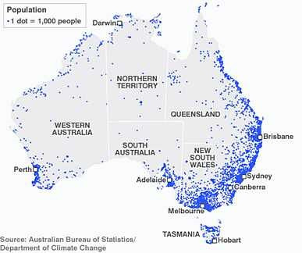Consider which **areas** of Australia are more densely **populated** – identify the **pattern** of where most people live?

Consider the location of **capital cities** and their populations – what do they all have in common? Which capital cities are the **exception** in terms of population?

This is a dot distribution map of Australia’s population

This is the focus of the PQE

1. Use the map below and the PQE method to describe Australia’s **lakes**.

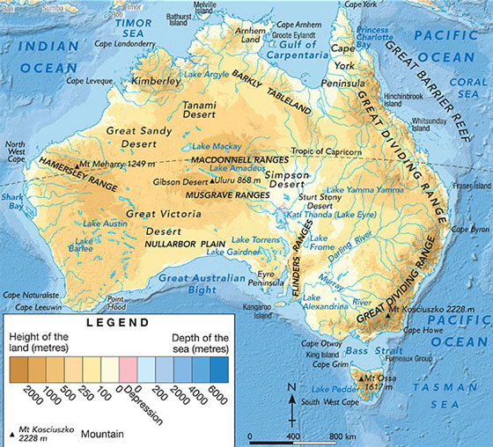

*Physical map of australia showing oceans and major mountain ranges, rivers, lakes and deserts*